Automated Development Authority

5.2.2014

Group Members:
Samia Shafique (1005067)
Md. Ahsanul Hadi (1005070)
Tamjid al Rahat (1005073)
Faysal Hossain Shezan (1005076)
Syeda Farzia Afroze (1005082)

Contents
Content |  | Page
Subsystems |  | 5
Actors |  | 6
Actors glossary |  | 7
1 | Form Submission and File Formation | 9
 | Use-case glossary | 9
 | Use case diagram | 10
 | 1.1 Submit Form | 11
 | 1.2: Payment Verification | 12
 | 1.3 File Forwarding | 13
2 | Land Use Clearance | 14
 | Use-case glossary | 14
 | Use case diagram | 15
 | 2.1 File receiving | 16
 | 2.2 Document and land verification | 17
 | 2.3 Verify and Forward | 18
 | 2.4 Survey | 19
 | 2.5 Application correction | 20
 | 2.6 Forward | 21
 | 2.7 DAP verification | 22
 | 2.8 File Forwarding | 23
 | 2.9 Clearance | 24
3 | Building Permit | 25
 | Use case glossary | 25
 | Use case diagram | 26
 | 3.1 File receiving | 27
 | 3.2 Maps verification and documents checking | 28
 | 3.3 Field work | 29
 | 3.4 Check inspection | 30
 | 3.5 Preliminary Checking | 31
 | 3.6 Forward to BC committee | 32
 | 3.7 Decision making | 33
 | 3.8 Permission approval | 34
 | 3.9 Permission rejection | 35
 | 3.10 Application correction | 36
4 | Special Project System | 37
 | Use case glossary | 37
 | Use case diagram | 38
 | 4.1 File receiving | 39
 | 4.2 Forward file | 40
 | 4.3 Meeting | 41
 | 4.4 Permission approval | 42
 | 4.5 Permission rejection | 43
5 | Appeal System | 44
 | Use case glossary | 44
 | Use case diagram | 45
 | 5.1 File receiving | 46
 | 5.2 Forward file | 47
 | 5.3 Board Hearing | 48
 | 5.4 Appeal approval | 49
 | 5.5 Appeal rejection | 50
6 | Complaint System | 51
 | Use case glossary | 51
 | Use case diagram | 52
 | 6.1 Receive complaint | 53
 | 6.2 Forward complaint | 54
 | 6.2 Complain inspection | 55
 | 6.3 Opening 2c file | 56
 | 6.4 Supervise inspection | 57
 | 6.5 Technical verification | 58
 | 6.6 Decision making | 59
 | 6.7 Sending notice | 60
 | 6.8 Enlist for taking action | 61
Subsystems
- File submission and formation system
- Land use clearance
- Building permit
- Special project permit
- Appeal system
- Complaint system

Actors

- Owner
- Bank
- Registry Officer
- Chairman
- Director
- Deputy Town Planner
- Assistant Town Planner
- Tracer
- Surveyor
- DAP officer
- Inspector
- Chief Inspector
- Authorize Officer
- Assistant Authorize Officer
- BC committee member
- Special committee member
- Board member
- LAW
- Complainer
- RAJUK Representative

Actor Glossary

Actor | Short-key | Activity Scope
Owner | OWN | Submit various forms ,views results ,submit appeal and complain
Tracer | TR | verifies clients documentation ,creates file , traces maps
Deputy Town Planner | DTP | issues Land use clearance , forwards file to ATP
Assistant Town Planner | ATP | verifies file
Surveyor | SRVR | does all the survey work
DAP officer | DAPO | checks the file with DAP
Inspector | ISP | Inspects land
Chief Inspector | CISP | verifies inspectors work
Authorize Officer | AO | manages several steps of issuing building permit
Assistant Authorize Officer | AAO | checks files for issuing building permit
BC committee member | BCCM | checks , analyses and approves building plan in a meeting
Special Project committee member | SPCM | checks , analyses and approves special project plan in a weekly meeting
Chairman | CHM | Receive and gives decision on appeal application
Board member | BM | checks and decides about an appeal in a meeting
Director | DIR | Receive files about special project permit  and issues permit to owner
Bank | BNK | receives money from owner
Registry Officer | RO | creates file and forward it
Law Section | LAW | verifies a complain
Complainer | COMP | complains to RAJUK about another land owner

Table : Actor Glossary

Subsystem 1: Form Submission and File Formation

USE-CASE GLOSSARY

Use-case No. / Use-case name | Description | Actor and Role
- Submit Form | Filling up and submitting required form with necessary documents and system generates a token. | OWN fills and submits form with necessary documents and system generates a token, RO receives the form .
1.2 Payment Verification | Bank receives payment and the generated token is verified | BNK receives payment and sends token to RO, OWN gives money receipt to RO, RO then verifies token
1.3 File forwarding | A file is created and forwarded to the corresponding section | RO creates and forwards file

USE-CASE GLOSSARY

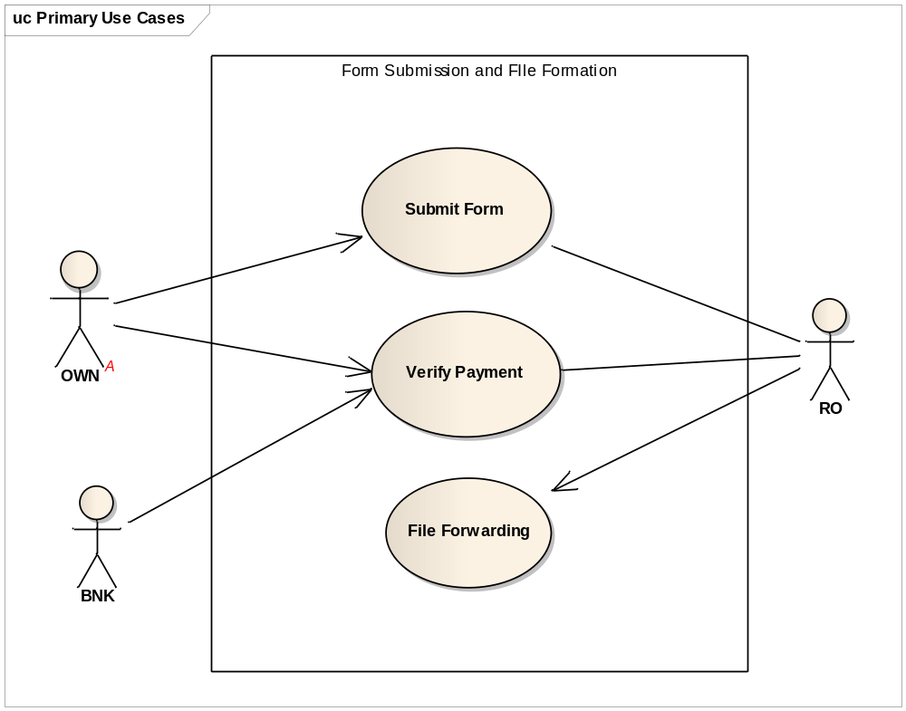
Fig: Use case Diagram of Form Submission and File Formation
Use-case 1.1: Submit Form
Use-case Name | Define Route and Price
Use-case ID | 1.1
Priority | High
Primary System Actor | OWN
External Receiver Actor | RO
Description | Filling up and submitting required form with necessary documents
Trigger | OWN
Table: Use-Case Narrative: Submit Form

Typical Course of Events
Actor Action | System Action
Step 1 : OWN Fills and Submits form | Step 2 :Generates a token
Step 3 : RO receives filled out form

Documentation
- Conclusion: Concludes when Registry Officer receives the form.
- Post-Condition: Inform Owner about the receiving of his/her form.
- Implementation Issues: GUI provided in website for the Owner.

Use-case 1.2: Verify Payment
Use-case Name | Define Route and Price
Use-case ID | 1.2
Priority | High
Primary System Actor | RO
Other Participating Actors | OWN , BNK
Description | Bank receives payment. The generated token is verified by RO. RO also receives bank receipt from OWN
Trigger | OWN
Table: Use-Case Narrative: Token Verification

Typical Course of Events
Actor Action | System Action
Step 1: OWN pays fee in bank and receives receipt
Step 2: BNK sends receipt number to RO
Step 3: RO receives receipt and token no from OWN | Step 4 :Verify receipt number and find the form with corresponding token number

Documentation
- Conclusion : When Registry Officer verifies the token and receipt number
- Post-Condition: Registry Officer finds the form for corresponding owner.
- Implementation Issues: Token number and receipt number stored in system
Use-case 1.3: File Forwarding
Use-case Name | Define Route and Price
Use-case ID | 1.3
Priority | High
Primary System Actor | RO
Other Participating actor | corresponding section
Description | A file is created and forwarded to the corresponding section by RO
Trigger | RO
Table: Use-Case Narrative: File Forwarding

Typical Course of Events
Actor Action | System Action
Step 1: RO creates a file and gives it a file number | Step 2 :file saved in Database
Step 3 : RO forwards file to corresponding section

Documentation
- Conclusion : Concludes when an actor in corresponding section receives file
- Post-Condition: inform RO that the file has been received
- Implementation Issues: File saved in File records

Subsystem 2: Land Use Clearance

USE-CASE GLOSSARY
Use-case No. / Use-case name | Description | Actor and Role
2.1 File receiving | A file enters the process | RO forwards a file to TR
2.2 Document and land verification | Documents and information of land is verified | TR verifies data and forwards to ATP
2.3 Verify and Forward | Document is verified and the verified document is sent to the SRVR | ATP verify and forward document to SRVR
2.4 Survey | SRVR survey the field and gives file to ATP | SRVR survey and gives file to ATP
2.5 Application correction | A correction of data is requested in case any wrong data is found | OWN is requested to correct any wrong information by ATP
2.6 Forward | ATP forwards the verified documents to DAP | ATP forward file to DAP
2.7 DAP verification | DAP checks if land use is in accordance with DAP | ATP forwards file for DAP checking
2.8 File Forwarding | ATP forwards file to DTP for final checking | ATP forwards file to DTP
2.9 Clearance | An approval is issued and if the approval is approved then DTP sends an approval letter and if it is rejected then DTP sends a rejected letter to OWN | DTP sends a letter to OWN

USE-CASE GLOSSARY

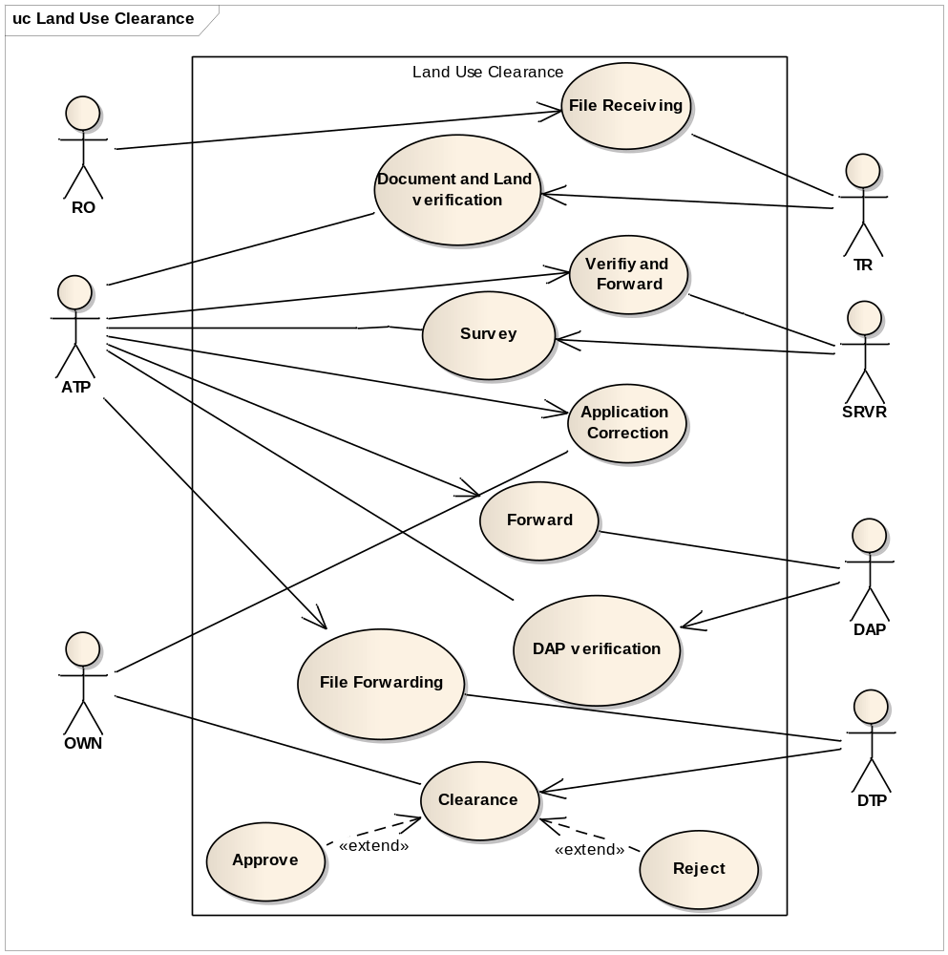
Fig: USE-CASE DIAGRAM of Land Use Clearance

Use-case 2.1: File Receiving
Use-case Name | Define Route and Price
Use-case ID | 2.1
Priority | High
Primary System Actor | RO
External Receiver Actor | TR
Description | A file enters the process
Trigger | RO
Table: Use-Case Narrative: File Receiving

Typical Course of Events
Actor Action | System Action
Step 1 : RO receives a file | Step 2 : Gives file a number
Step 3 : RO forwards file to TR | Step 4 : Update file status

Documentation
- Conclusion : Concludes when TR receive the file
- Post-Condition: inform RO that file has been received
- Implementation Issues: Notify TR about file and file updating

Use-case 2.2: Document and Land Verification
Use-case Name | Define Route and Price
Use-case ID | 2.2
Priority | High
Primary System Actor | TR
External Receiver Actor | ATP
Description | Documents and information of land is verified
Trigger | TR
Table: Use-Case Narrative: Document and Land verification

Typical Course of Events
Actor Action | System Action
Step 1 : TR verifies files information, land position | Step 2 : Save file in Database
Step 3 :ATP receives verified documents | Step 4: Update file status

Documentation
- Conclusion : Concludes when ATP receive verified file
- Post-Condition: Inform TR about the file
- Implementation Issues: File current status and location updating
Use-case 2.3: Verify and Forward
Use-case Name | Define Route and Price
Use-case ID | 2.3
Priority | High
Primary System Actor | ATP
External Receiver Actor | SRVR
Description | Document is verified and the verified document is sent to the SRVR
Trigger | ATP
Table: Use-Case Narrative: Verify and Forward

Typical Course of Events
Actor Action | System Action
Step 1 : ATP verifies files | Step 2: Update file information
Step 3 : ATP forwards file to SRVR | Step 4: Update file status

Documentation
- Conclusion : Concludes when SRVR receive verified file
- Post-Condition: Inform ATP about the file
- Implementation Issues: File added to SRVR’s list
Use-case 2.4: Survey
Use-case Name | Define Route and Price
Use-case ID | 2.4
Priority | High
Primary System Actor | SRVR
External Receiver Actor | ATP
Description | SRVR survey the field and gives file to ATP
Trigger | SRVR
Table: Use-Case Narrative: Survey

Typical Course of Events
Actor Action | System Action
Step 1 : SRVR survey the location and verify information
Step 2 :ATP receives verified documents | Step 3: Update file status

Documentation
- Conclusion : Concludes when ATP receive verified file
- Post-Condition: SRVR receives file and get notified
- Implementation Issues: Verification result saved in database
Use-case 2.5: Application Correction
Use-case Name | Define Route and Price
Use-case ID | 2.5
Priority | High
Primary System Actor | ATP
External Receiver Actor | OWN
Description | A correction of data is requested in case any wrong data is found
Trigger | OWN
Table: Use-Case Narrative: Application Correction

Typical Course of Events
Actor Action | System Action
Step 1 : OWN is requested to submit corrected data if any wrong information is found
Step 2 :ATP receives and verifies the corrected data | Step 3 : Update database and status of file

Documentation
- Conclusion : Concludes when ATP receive corrected file
- Post-Condition: Wrong information need to be replaced by right information
- Implementation Issues: Updating database with current status of file
Use-case 2.6: Forward
Use-case Name | Define Route and Price
Use-case ID | 2.6
Priority | High
Primary System Actor | ATP
External Receiver Actor | DAP
Description | ATP forwards the verified documents to DAP
Trigger | ATP
Table: Use-Case Narrative: Forward

Typical Course of Events
Actor Action | System Action
Step 1 : ATP forwards file to DAP for further investigation | Step 2 :Update file current status

Documentation
- Conclusion : Concludes when DAP receive file
- Post-Condition: inform ATP that file has been received
- Implementation Issues: File added to DAP’s list

Use-case 2.7: Dap Verification
Use-case Name | Define Route and Price
Use-case ID | 2.7
Priority | High
Primary System Actor | DAP
External Receiver Actor | ATP
Description | DAP checks if land use is in accordance with DAP
Trigger | DAP
Table: Use-Case Narrative: DAP Verification

Typical Course of Events
Actor Action | System Action
Step 1 : DAP checks if the given information is in accordance with the plan | Step 2 :Update file status
Step 3 : Forwards the file to ATP | Step 4 : Update file current status

Documentation
- Conclusion : Concludes when ATP receive verified file
- Post-Condition: inform DAP that file has been received
- Implementation Issues: Notify ATP about the file
Use-case 2.8: File Forwarding
Use-case Name | Define Route and Price
Use-case ID | 2.8
Priority | High
Primary System Actor | ATP
External Receiver Actor | DTP
Description | ATP forwards file to DTP for final checking
Trigger | ATP
Table: Use-Case Narrative: File Forwarding

Typical Course of Events
Actor Action | System Action
Step 1 : ATP forward file to DTP | Step 2 :Update file status

Documentation
- Conclusion : Concludes when DTP receive verified file
- Post-Condition: Inform ATP about the file
- Implementation Issues: File added to DTP’s list

Use-case 2.9: Clearance
Use-case Name | Define Route and Price
Use-case ID | 2.9
Priority | High
Primary System Actor | DTP
External Receiver Actor | OWN
Description | An approval is issued and if the approval is approved then DTP sends an approval letter and if it is rejected then DTP sends a rejected letter to OWN
Trigger | DTP
Table: Use-Case Narrative: Clearance
Typical Course of Events
Actor Action | System Action
Step 1 : An approval is issued | Step 2 : Update file status
Step 3 : Approval or Rejected letter is sent to OWN by DTP | Step 4 : Update the Database and Soft copy is generated and sent to OWN
Documentation
- Conclusion : Concludes when DTP sends letter to OWN
- Post-Condition: If approved , file is closed , else OWN can appeal against decision
- Implementation Issues: Soft copy and result of the approval is published in the website

Subsystem 3: Building Permit

USE-CASE GLOSSARY
Use-case No. / Use-case name | Description | Actor and Role
3.1 File receiving | A file is received | RO forwards file which TR receives
3.2 Maps verification and documents checking | The information is verified and forwarded | TR verifies the location and documents, file forwarded to ISP
3.3 Field work | The land is inspected physically and data is collected | ISP inspects the land and forwards data to CISP
3.4 Check inspection | Data is rechecked and forwarded | CISP rechecks data and forwards to AAO
3.5 Preliminary Checking | The calculations and building structure is checked | AAO performs a preliminary check and forwards to AO
3.6 Forward to BC committee | Data is checked and forwarded | AO rechecks data and forwards file to BCCM
3.7 Decision making | A decision is made and recorded | A decision is made by BCCM and AO records it
3.8 Permission approval | A permission approval letter is dispatched | AO sends a permission approval letter to OWN
3.9 Permission rejection | A permission rejection letter is dispatched | AO sends a permission rejection letter to OWN
3.10 Application correction | A correction of data is requested in case any wrong data is found | OWN is requested to correct any wrong information by TR, CISP or AO

USE-CASE GLOSSARY

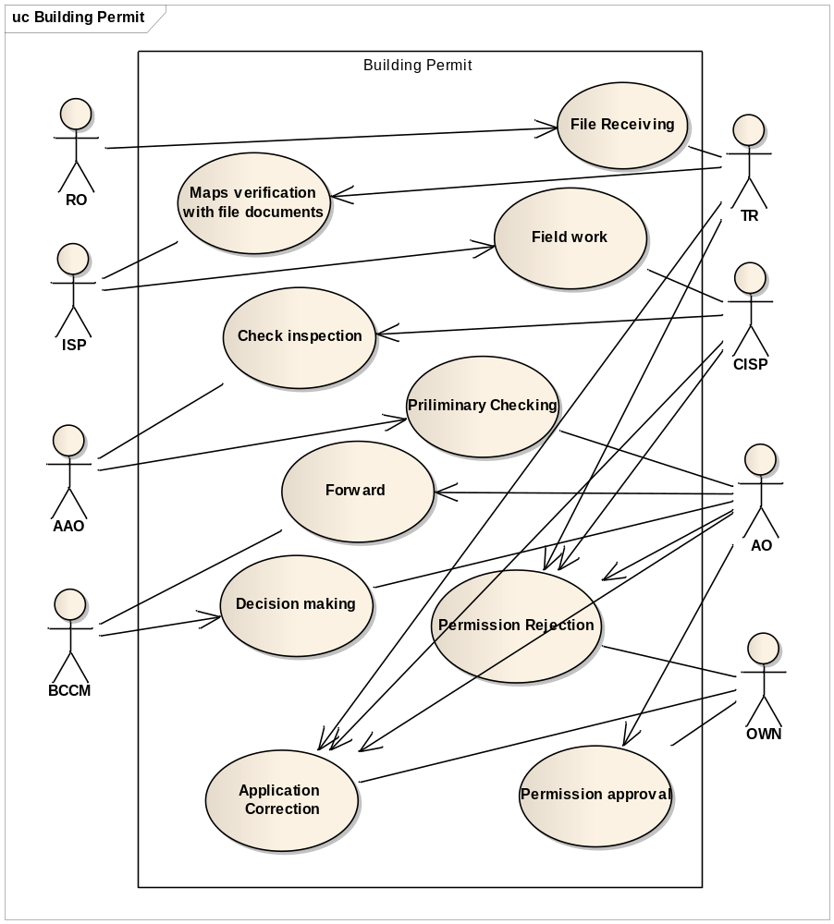
Fig: USE-CASE DIAGRAM of Building Permit
Use-case 3.1 : File receiving
Use-case Name | Define Route and Price
Use-case ID | 3.1
Priority | High
Primary System Actor | RO
External Receiver Actor | TR
Description | A file is received
Trigger | RO

Typical Course of Events
Actor Action | System Action
Step 1: RO categorizes a file as a building permit file | Step 2: System forwards the file to TR
Step 3: TR receives file | Step 4: An entry is made

Documentation
- Conclusion : A file is entered for processing in the building permit section
- Post-Condition: TR has access to the new file
- Implementation Issues: The file is maintained by the system and TR receives a notification after the system forwards the file

Use-case 3.2 : Maps verification and document checking
Use-case Name | Define Route and Price
Use-case ID | 3.2
Priority | High
Primary System Actor | TR
External Receiver Actor | ISP
Description | The information is verified and forwarded
Trigger | TR

Typical Course of Events
Actor Action | System Action
Step 1: TR verifies that the maps of the land shown match with the CS, RS and MS | Step 2: The location information is stored in the system
Step 3: TR checks that the proper documents are submitted | Step 4: The documents are uploaded
Step 5: TR forwards file to ISP | Step 6: System notifies ISP of a new file in his tray
Step 7: ISP receives file

Documentation
- Conclusion : Concludes when ISP receives a file with all necessary documents and maps
- Post-Condition: ISP has a file with maps and necessary documents.
- Implementation Issues: The map location and documents information is updated in the system

Use-case 3.3 : Field work
Use-case Name | Define Route and Price
Use-case ID | 3.3
Priority | High
Primary System Actor | ISP
External Receiver Actor | CISP
Description | The land is inspected physically and data is collected
Trigger | ISP

Typical Course of Events
Actor Action | System Action
Step 1: ISP physically inspects the data and collects information on the land | Step 2: The data is forwarded to CISP
Step 3: CISP receives file

Documentation
- Conclusion : Concludes when CISP receives information that the ISP collected.
- Post-Condition: Information collected by ISP is forwarded to CISP for verification
- Implementation Issues: Inspection data is stored in a database and forwarded to CISP

Use-case 3.4 : Check inspection
Use-case Name | Define Route and Price
Use-case ID | 3.4
Priority | High
Primary System Actor | CISP
External Receiver Actor | AAO
Description | Data is rechecked and forwarded
Trigger | CISP

Typical Course of Events
Actor Action | System Action
Step 1: CISP checks that the data collected by ISP is valid | Step 2: The data is uploaded in the database and forwarded to AAO
Step 3: AAO receives the file

Documentation
- Conclusion : Concludes when AAO receives the inspected file
- Post-Condition: AAO is notified of an inspected file in his tray and he receives it.
- Implementation Issues: The inspection data is updated in the system and forwarded to AAO

Use-case 3.5 : Preliminary checking
Use-case Name | Define Route and Price
Use-case ID | 3.5
Priority | High
Primary System Actor | AAO
External Receiver Actor | AO
Description | The calculations and building structure is checked
Trigger | AAO

Typical Course of Events
Actor Action | System Action
Step 1: AAO checks the technical aspects of the building plan | Step 2: The data collected by the AAO and forwarded to AO
Step 3: AO receives the file

Documentation
- Conclusion : Concludes when AO receives a file with a preliminary check
- Post-Condition: AO is notified of a file forwarded by AAO waiting to be authorized
- Implementation Issues: The data collected by AAO is forwarded to AO

Use-case 3.6 : Forward to BC committee
Use-case Name | Define Route and Price
Use-case ID | 3.6
Priority | High
Primary System Actor | AO
External Receiver Actor | BCCM
Description | Data is checked and forwarded
Trigger | AO

Typical Course of Events
Actor Action | System Action
Step 1: AO verifies that the file is properly checked by AAO | Step 2: The data is uploaded in the database and forwarded to BCCM
Step 3: BCCM receives the file

Documentation
- Conclusion : Concludes when BCCM receives an authorized file
- Post-Condition: BCCM has an authorized file to discuss in a board meeting
- Implementation Issues: The authorization data is uploaded

Use-case 3.7 : Decision making
Use-case Name | Define Route and Price
Use-case ID | 3.7
Priority | High
Primary System Actor | BCCM
External Receiver Actor | AO
Description | A decision is made and recorded
Trigger | BCCM

Typical Course of Events
Actor Action | System Action
Step 1: a decision is made about the building plan at a committee meeting by BCCM | Step 2: The outcome of the meeting is stored in the system and forwarded to the AO

Documentation
- Conclusion : Concludes when BCCM has made a decision about the building plan
- Post-Condition: AO is notified of the decision made at the meeting
- Implementation Issues: The outcome of the meeting is entered into the system
Use-case 3.8 : Permission approval
Use-case Name | Define Route and Price
Use-case ID | 3.8
Priority | High
Primary System Actor | AO
External Receiver Actor | OWN
Description | A permission approval letter is dispatched
Trigger | AO

Typical Course of Events
Actor Action | System Action
Step 1:AO updates data about the plan approval in the system and enters a letter to be forwarded to the OWN | Step 2: System notifies OWN of the plan approval and closes the file

Documentation
- Conclusion : Concludes when OWN recieves a plan approval
- Post-Condition: OWN receives a letter stating the plan approval
- Implementation Issues: A GUI interface tells OWN that his plan is approved

Use-case 3.9 : Permission rejection
Use-case Name | Define Route and Price
Use-case ID | 3.9
Priority | High
Primary System Actor | AO
External Receiver Actor | OWN
Description | A permission rejection letter is dispatched
Trigger | AO

Typical Course of Events
Actor Action | System Action
Step 1:AO updates data about the plan approval in the system and enters a rejection letter to be forwarded to OWN | Step 2: System notifies OWN of the plan rejection and closes the file

Documentation
- Conclusion : Concludes when OWN receives a plan rejection
- Post-Condition: OWN receives a letter stating the plan rejection
- Implementation Issues: A GUI interface tells OWN that his plan is rejected

Use-case 3.10 : Application correction
Use-case Name | Define Route and Price
Use-case ID | 3.10
Priority | High
Primary System Actor | TR, CISP, AO
External Receiver Actor | OWN
Description | A correction of data is requested in case any wrong data is found
Trigger | TR, CISP, AO

Typical Course of Events
Actor Action | System Action
Step 1 : TR, CISP or AO inform OWN about wrong information
Step 2:OWN provides any necessary corrections | Step 3: System notifies one of TR, CISP or AO of the correction depending on the nature of the correction

Documentation
- Conclusion : Concludes when TR, CISP , AO receive corrected document
- Post-Condition: one of TR, CISP or AO receives the correction
- Implementation Issues: OWN enters corrected data in a GUI interface and forwards to related officer

Subsystem 4: Special Project System

USE-CASE GLOSSARY
Use-case No. / Use-case name | Description | Actor and Role
4.1 File receiving | A file is received | RO forwards file which DIR receives
4.2 Forward file | The file is forwarded to the meeting | DIR forwards the project file to SPCM
4.3 Meeting | A decision is made about the project | SPCM makes decision at a meeting and lets DIR know the outcome
4.4 Permission approval | The permission is approved | DIR sends an approving letter to OWN
4.5 Permission rejection | The permission is rejected | DIR sends a rejection letter to OWN

USE-CASE GLOSSARY

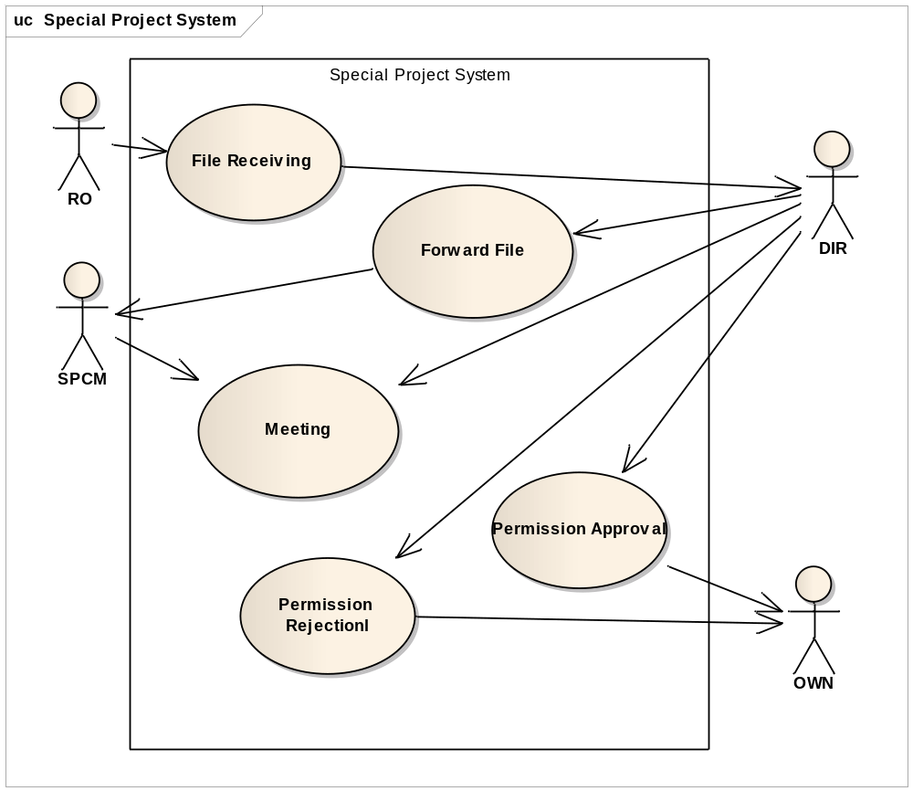
Fig: Use-case Diagram of Special Project System
Use-case 4.1: File receiving
Use-case Name | Define Route and Price
Use-case ID | 4.1
Priority | High
Primary System Actor | RO
External Receiver Actor | DIR
Description | A file is received
Trigger by | RO
Table: Use-Case Narrative: File Receiving
Typical Course of Events
Actor Action | System Action
Step 1 : RO forwards a file to DIR
Step 2 : DIR receives the file

Documentation
- Conclusion: Concludes when Director of board receives a file.
- Post-Condition: Inform Director about the receiving of file.
- Implementation Issues : notify Director about the receiving of file and showing file data

Use-case 4.2:Forward file
Use-case Name | Define Route and Price
Use-case ID | 4.2
Priority | High
Primary System Actor | DIR
External Receiver Actor | SPCM
Description | The file is forwarded to the committee members
Trigger | DIR
Table: Use-Case Narrative: Forward file
Typical Course of Events
Actor Action | System Action
Step 1: DIR forwards the file | Step 2: A copy of the file is sent to SPCM
Step 3: Each SPCM receives a copy of the file

Documentation
- Conclusion: When special committee members receives a copy of the file.
- Post-Condition: Inform Special Committee members about receiving a new file.
- Implementation Issues: notify Special Committee members about the receiving of file and showing file data
Use-case 4.3:Meeting
Use-case Name | Define Route and Price
Use-case ID | 4.3
Priority | High
Primary System Actor | SPCM
External Receiver Actor | DIR
Description | SPCM makes decision at a meeting and lets DIR know the outcome
Trigger | SPCM
Table: Use-Case Narrative: Meeting
Typical Course of Events
Actor Action | System Action
Step 1: A meeting with SPCM is held to take decision
Step 2: SPCM notifies DIR about the outcome of the meeting | Step 3: Detail outcome of the meeting is sent to the DIR
Step 4: DIR receives the detail outcome of the meeting

Documentation
- Conclusion: Concludes when Director of Board receives details outcome of the meeting.
- Post-Condition: inform director about the meeting and its outcome.
- Implementation Issues: Records of outcome of the meeting is saved in system database.

Use-case 4.4:Permission Approval
Use-case Name | Define Route and Price
Use-case ID | 4.4
Priority | High
Primary System Actor | DIR
External Receiver Actor | OWN
Description | The permission is approved and an approval letter is sent to the Owner
Trigger | DIR
Table: Use-Case Narrative: Approval
Typical Course of Events
Actor Action | System Action
Step 1: DIR submits corresponding approval form for special project permit | Step 2: A soft copy of the approval letter is generated and sent to OWN
 | Step 3: Owner is informed about the approval letter and a generated approval letter is sent

Documentation
- Conclusion: Concludes when Owner receives the approval letter.
- Post-Condition: inform owner about the approval
- Implementation Issues: An approval letter is generated and Records are kept in database by the system

Use-case 4.5:Permission Rejection
Use-case Name | Define Route and Price
Use-case ID | 4.5
Priority | High
Primary System Actor | DIR
External Receiver Actor | OWN
Description | The permission is rejected and a rejection letter is sent to the Owner
Trigger | DIR
Table: Use-Case Narrative: Rejection
Typical Course of Events
Actor Action | System Action
Step 1: DIR submits corresponding rejection form for special project permit | Step 2: A soft copy of the rejection letter is generated and sent to OWN
 | Step 3: Owner is informed about the rejection and a generated rejection letter is sent

Documentation
- Conclusion: Concludes when Owner receives the rejection letter.
- Post-Condition: inform owner about the rejection
- Implementation Issues: An rejection letter is generated and Records are kept in database by the system

Subsystem 5: Appeal System

USE-CASE GLOSSARY
Use-case No. / Use-case name | Description | Actor and Role
5.1 File receiving | A file is received | RO forwards file which CHM receives
5.2 Forward file | The file is forwarded to the board | CHM forwards the project file to BM and notifies RR, OWN
5.3 Board Hearing | A decision is made | BM makes a decision in Board hearing in presence of OWN and RR
5.4 Appeal approval | The appeal is approved | CHM sends an approving letter to OWN
5.5 Appeal rejection | The appeal is rejected | CHM sends a rejection letter to OWN

USE-CASE GLOSSARY

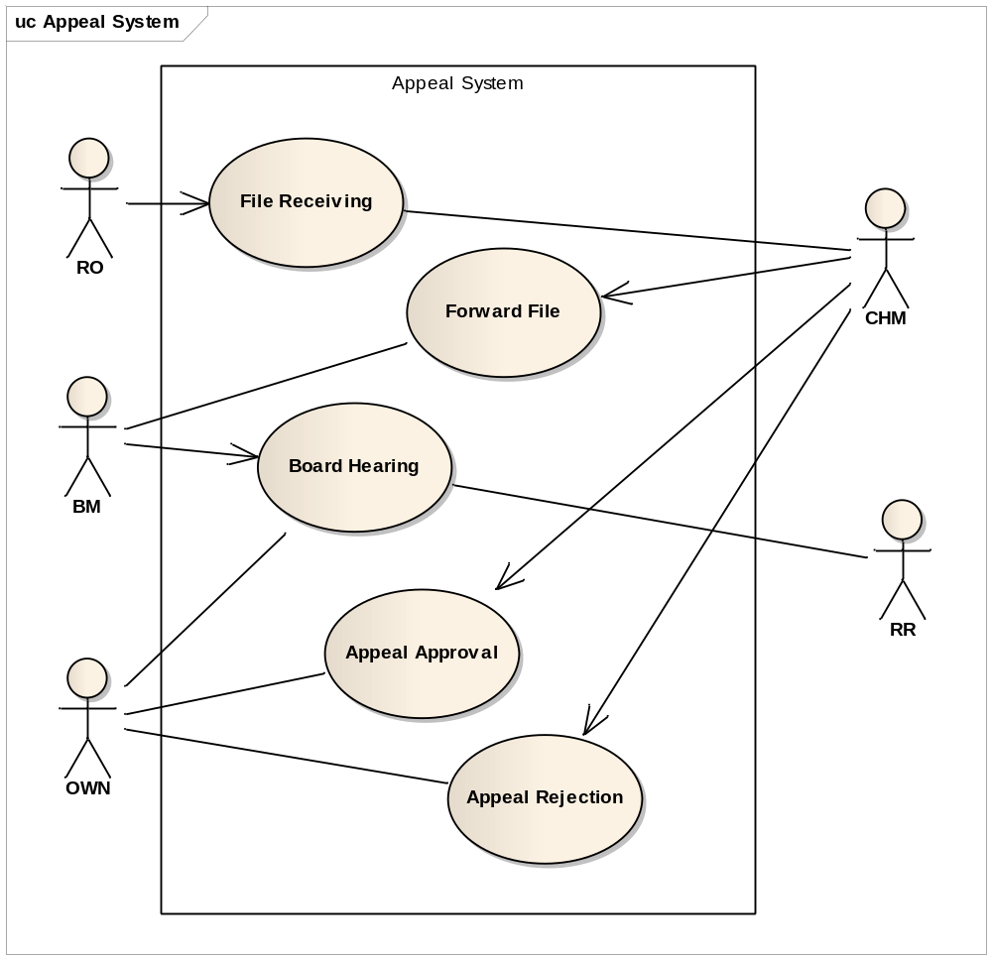

Use-case 5.1: File Receiving
Use-case Name | Define Route and Price
Use-case ID | 5.1
Priority | High
Primary System Actor | CHM
External Sender Actor | RO
Description | RO forwards file which CHM receives
Trigger | RO
Table: Use-Case Narrative: File Receiving

Typical Course of Events
Actor Action | System Action
Step 1: RO sends a file
Step 2 : CHM receives the file

Documentation
- Conclusion : concludes when CHM receives the file
- Post-Condition: inform RO that the file has been received
- Implementation Issues: File added to CHM’s list of files

Use-case 5.2: Forward File
Use-case Name | Define Route and Price
Use-case ID | 5.2
Priority | High
Primary System Actor | CHM
Other participating Actors | BM , RR , OWN
Description | File is checked and forwarded to Board Members.  A notification about board meeting is also sent to RR, OWN.
Trigger | CHM
Table: Use-Case Narrative: Forward File

Typical Course of Events
Actor Action | System Action
Step 1 : CHM checks and verifies the appeal
Step 2: Forwarded to BM | Step 3 : Notification sent to RR, OWN about Board hearing

Documentation
- Conclusion : Concludes when RR and OWN receives notification
- Post-Condition: Inform CHM that BM has received the file
- Implementation Issues: File added to board meeting list

Use-case 5.3: Board Hearing
Use-case Name | Define Route and Price
Use-case ID | 5.3
Priority | High
Primary System Actor | BM
External Receiver Actor | RR,OWN
Description | BM makes a decision in Board hearing in presence of OWN and RR
Trigger | BM
Table: Use-Case Narrative: Board Hearing

Typical Course of Events
Actor Action | System Action
Step 1 :Board hearing held | Step 2 : Outcome Recorded in the file

Documentation
- Conclusion : Concludes when a decision is taken in meeting
- Post-Condition: inform all actors about the outcome
- Implementation Issues: outcome stored in corresponding file

Use-case 5.4: Appeal approval
Use-case Name | Define Route and Price
Use-case ID | 5.4
Priority | High
Primary System Actor | CHM
External Receiver Actor | OWN
Description | CHM sends an approving letter to OWN
Trigger | CHM
Table: Use-Case Narrative: Appeal Approval

Typical Course of Events
Actor Action | System Action
Step 1: CHM sends Approval letter
Step 2: Own receives Approval letter

Documentation
- Conclusion : Concludes when OWN receives letter
- Post-Condition: File is closed
- Implementation Issues: result recorded in file

Use-case 5.5: Appeal Rejection
Use-case Name | Define Route and Price
Use-case ID | 5.5
Priority | High
Primary System Actor | CHM
External Receiver Actor | OWN
Description | CHM sends an Rejection letter to OWN
Trigger | CHM
Table: Use-Case Narrative: Appeal Rejection

Typical Course of Events
Actor Action | System Action
Step 1: CHM sends Rejection letter
Step 2: Own receives Rejection letter

Documentation
- Conclusion : Concludes when OWN receives letter
- Post-Condition: File is closed
- Implementation Issues: result recorded in file

Subsystem 6: Complaint System

USE-CASE GLOSSARY
Use-case No. / Use-case name | Description | Actor and Role
6.1 Receive complaint | A complaint is received | AO receives a complaint from COMP
6.2 Forward complaint | Complaint is forwarded | AO forwards complaint to ISP
6.2 Complain inspection | The complaint is inspected | ISP inspects complaint
6.3 Opening 2c file | A 2c file is opened | ISP opens 2c file for the complaint and forwards to CISP
6.4 Supervise inspection | The file is rechecked | CISP rechecks file and forwards to AAO
6.5 Technical verification | Technical data is verified | AO and AAO verifies the technical aspects and forwards to LAW
6.6 Decision making | A decision is made about the complaint | LAW makes a decision and lets AO, COMP know the outcome
6.7 Sending notice | A notice conveying the outcome is dispatched | AO sends a notice to the OWN notifying him of the outcome
6.8 Enlist for taking action | The complaint is enlisted for taking aciton | AO lists a new entry for which an aciton is taken

USE CASE GLOSSARY

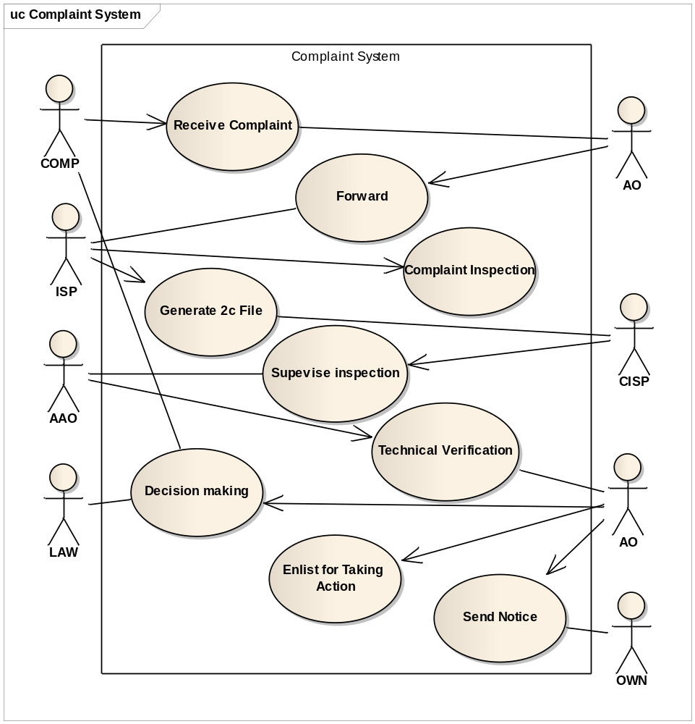
Fig: Use-case Diagram of Complaint System
Use-case 6.1: Receive Complaint
Use-case Name | Define Route and Price
Use-case ID | 6.1
Priority | High
Primary System Actor | COMP
External Receiver Actor | AO
Description | A complaint is received by AO
Trigger by | COMP

Typical Course of Events
Actor Action | System Action
Step 1 : COMP submits a complaint along with specific data | Step 2: complaint is forwarded to AO
Step 3 : AO receives the complaint | Step 4: Complaint is saved in system database

Documentation
- Conclusion: Concludes when Authorized Officer receives the complaint.
- Post-Condition: Inform Authorized Officer about the receiving of complaint and an entry is made by the system.
- Implementation Issues : notify Authorized Officer about the receiving of complaint and showing corresponding data
Use-case 6.2:Forward complaint
Use-case Name | Define Route and Price
Use-case ID | 6.2
Priority | High
Primary System Actor | AO
External Receiver Actor | ISP
Description | The complaint is forwarded to ISP
Trigger by | AO

Typical Course of Events
Actor Action | System Action
Step 1: AO forwards the file | Step 2: Complaint and corresponding data are sent to ISP
Step 3: ISP receives the complaint

Documentation
- Conclusion: When Inspector receives the complaint and corresponding data.
- Post-Condition: Inform Inspector about receiving a complaint
- Implementation Issues: notify Inspector about the receiving of complaint and showing complaint data
Use-case 6.3:Complaint Inspection
Use-case Name | Define Route and Price
Use-case ID | 6.3
Priority | High
Primary System Actor | ISP
External Receiver Actor
Description | ISP inspects on the complain
Trigger | ISP

Typical Course of Events
Actor Action | System Action
Step 1: ISP inspects the complain data and inputs inspected data | Step 2: inspected data is saved

Documentation
- Conclusion: Concludes when inspector records data
- Post-condition: An entry for the inspected data is made
- Implementation Issues: Inspected data is recorded in system database

Use-case 6.4:Opening 2c file
Use-case Name | Define Route and Price
Use-case ID | 6.4
Priority | High
Primary System Actor | ISP
External Receiver Actor | CISP
Description | ISP opens a 2c file for the complaint and forward it to CISP
Trigger by | ISP

Typical Course of Events
Actor Action | System Action
Step 1: ISP opens a 2c file | Step 2: A 2c file is created for corresponding complain
Step 3: ISP forwards the 2c file along with other complain data to CISP | Step 4: 2c file is sent to CISP and CISP is notified
Step 5: CISP receives 2c file

Documentation
- Conclusion: Concludes when chief inspector receives 2c file
- Post-condition: inform chief inspector about receiving the 2c file
- Implementation Issues: records of the 2c files are maintained by the system

Use-case 6.5:Supervise Inspection
Use-case Name | Define Route and Price
Use-case ID | 6.4
Priority | High
Primary System Actor | CISP
External Receiver Actor | AAO
Description | Complaint file and inspected data is rechecked and forwarded to AAO
Trigger | CISP

Typical Course of Events
Actor Action | System Action
Step 1: CISP recheck complain file forward to AAO | Step 2: Complain file is forwarded to AAO with inspected data
Step 3: AAO receives the complaint file and inspected data

Documentation
- Conclusion: Concludes when Assistant Authorized Officer receives the complaint file along with 2c file
- Post-Condition: inform Assistant Authorized Officer about receiving a complaint file
- Implementation Issues:Assistant Authorized Officer is notified about receiving of the complaint file

Use-case 6.6:Technical Verification
Use-case Name | Define Route and Price
Use-case ID | 6.6
Priority | High
Primary System Actors | AO,AAO
External Receiver Actor | LAW
Description | Data is verified from technical aspects by AO and AAO and then forwarded to LAW section
Trigger by | AAO

Typical Course of Events
Actor Action | System Action
Step 1: Data is verified by AO and AAO

Documentation
- Conclusion: Concludes when authorized officers verify data
- Post-Condition: ??
- Implementation Issues: ???

Use-case 6.7:Decision Making
Use-case Name | Define Route and Price
Use-case ID | 6.7
Priority | High
Primary System Actor | LAW
Other Participating Actors | AO,COMP
Description | A decision is made about the complaint
Trigger | LAW

Typical Course of Events
Actor Action | System Action
Step 1: LAW section makes the decision | Step 2: AO and COMP are notified about the decision

Documentation
- Conclusion: Concludes when AO and COMP are notified about the decision.
- Post-Condition: inform owner about the rejection
- Implementation Issues: Records of the decision is kept by system database

Use-case 6.8:Sending Notice
Use-case Name | Define Route and Price
Use-case ID | 6.8
Priority | High
Primary System Actor | AO
External Receiver Actor | OWN
Description | A notice conveying the outcome is dispatched
Trigger | AO

Typical Course of Events
Actor Action | System Action
Step 1: AO gives a notice to OWN | Step 2: system generates a notice and sends it to OWN and other respective office(if necessary)
Step 3: OWN is notified and given a notice about the decision made

Documentation
- Conclusion: Concludes when Owner receives the notice
- Post-Condition: inform owner about the notice
- Implementation Issues: generates a notice and keeps record of the notice given

Use-case 6.9:Enlist for taking action
Use-case Name | Define Route and Price
Use-case ID | 6.9
Priority | High
Primary System Actor | AO
External Receiver Actor
Description | The complaint is enlisted for taking action
Trigger | AO

Typical Course of Events
Actor Action | System Action
Step 1: AO enlist the complain for taking necessary action | Step 2: system enlist complain data for the action to be taken

Documentation
- Conclusion: Concludes when AO enlists the complaint outcome to take action
- Post-Condition: An entry of the complaint is made
- Implementation Issues: list for the action to be taken is maintained by the system

